**Author**

Siddhant Nikhil Ghodke

22f3000388

22f3000388@ds.study.iitm.ac.in

I am currently pursuing B.Tech in Electronics and Telecommunication along with B.S. inData Science and Applications from IITM. I am passionate about machine learning and data science, and aspire to become an AI/ML engineer.

**Description**

A Quiz app is to be created with an Admin as a superuser and users who can attempt quizzes. Admin can create, manage, edit and delete users, quizzes, chapters, and subjects. User and Admin can see summary charts.

**Technologies used**

The main skeleton of the app was written using flask, “redirect” and “url_for” extensions were used to render HTML pages on the web. “Session” was used to create user session, Flash was used to flash messages on the server. The Database and the superuser was created programmatically using python. FlaskForms were used to create all sorts of forms like login, signup, add chapters/users/subjects etc.

**DB Schema Design**

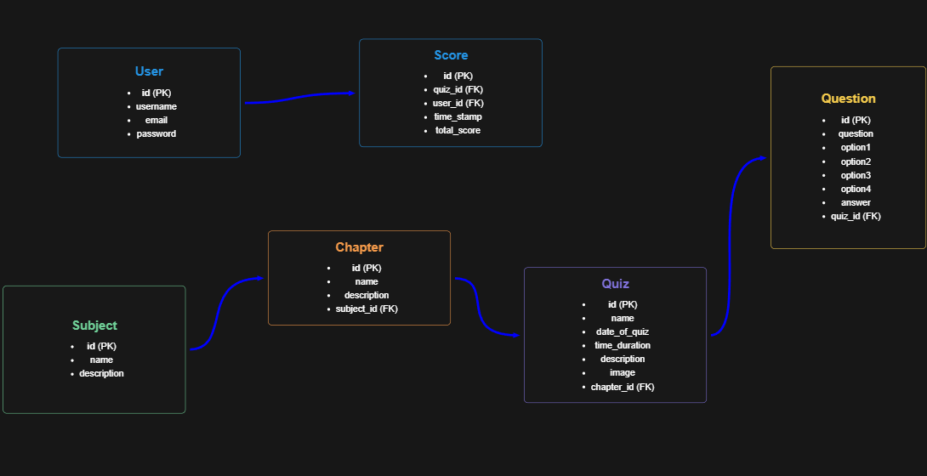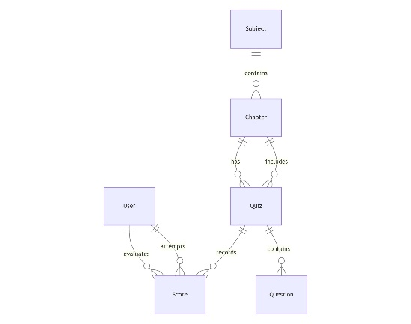

I have created 6 tables – Quiz, User, Subject, Chapter, Questions, and score. Subject contains Chapters and quiz is directly linked to chapters. The quiz table is also linked to user and user will attempt the quiz and quiz is then linked to scores to record the scores of quiz given by user.

**Architecture and Features**

My project contains the main file which is the python application and template and static folders, template folder contains all the HTML code that is to be rendered on the server. To distinguish between the user and admin template I have created an admin folder in the template section which contains all the HTML templates which are directly associated with the admin like manage quiz/subjects/chapters/users and editing features. Both admin and user templates have a base template which is inherited in every template which contains the navbar from bootstrap. All the Core Functionalities with respect to admin and user have been implemented properly with additional to some recommended and optional functionality like timer and aesthetics.

**Video**

<https://drive.google.com/file/d/1E91-GZ0EZ4dKy_-mRk-tqXQsUGLZYC1I/view?usp=sharing>